1.Find the Z- Transform of:
x[n] = a^{n} u [n], for what value of a the Z-Transform exist?
2. Define LTI system. Mention and explain the properties of LTI system.
3.Find the Inverse Z-Transform for the given Transfer function,
H(z) = 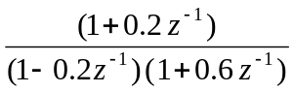
4.For the given system,
y (n) = 0.7 y(n-1) – 0.1 y (n – 2) + x (n) – 0.5 x (n – 1) plot the pole zero diagram
5.Given x(n) = a^{n} sin won u (n) Find its z-transform
6.Find out the output of the LTI system when input x(n) = { 1,1, 2} and impulse response h(n) = { 1, 2} is given
7.Write Short notes on :
- Energy and Power signal
- Properties of LTI system
- Region of Convergence

8. Define Energy and power signal. Calculate the energy of the signal; x(t) = e^{-at} for a>0.
9. What do you mean by Time Invariant and causal system? Check the following system for time invariance and causality. y[n] = a x[n]+b
10.What is the condition for an LTI system to be stable? Check the following system for BIBO stability:
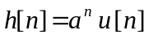
Is this system causal, why?
11. .Define z-transform. Determine the z-transform and ROC of the signal: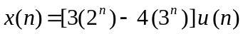
12. A discrete time system is given as:
- What is this system, FIR or IIR?
- Plot the pole-zero diagrams.
- Plot the magnitude Response.
13.Use the z-transform to perform the convolution of the following two sequences: 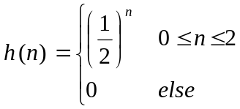
and

15.Define and describe LTI system. Also, discuss stability and memory of that system.
14. Define causal and non-causal system with example. Consider a continuous time system with input x(t) and output y(t) related by y(t) = x (sin (t)). Check the causality, shift variancy, linearity and stability of this system.

For the given system: plot the pole-zero diagram.
y(n) = 0.7 y(n – 1) – 0.1 y(n – 2) + x(n) – 0.5 x (n – 1)

17..Prove whether the system h[n] = 5x[n] +2 is linear or not.
16.Determine the Fourier Transform of an exponentially decaying signal x(t) = e^{-at} u(t), a>0.
18. .Find the inverse z transform of x(z) = 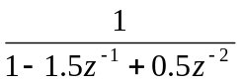with ROC:0.5<|z|<1.
19. What is aliasing effect? Consider the analog signal x_{a}(t) = 3cos200t+5sin6000t+10cos12000t. What is the Nyquist rate for this signal , what is the discrete time signal obtained after sampling with sampling rate F_{s} = 5000 samples/s.

iv) Also plot the pole – zero diagram of the system.
20.Given the system
y[n] = 2y [n-1] – y[n-2] + x[n] – 5x[n-1]
i) Find system function H(Z)
ii) Is this system IIR or FIR?
iii) Find out the frequency response.

21. What are the dirichlet condtions for the existence of fourier transform. Explain the properties of fourier transform.
22. What is SSP? Explain the block diagram of signal processing elements in brief.
23. Classify system. Explain the condition of a LTI system to be a BIBO stable.
24. Prove that the convolution of a two time domain signals is equal to the multiplication of their corresponding transform.
25. Determine the convolution of :
x1(n)=U(n+2)-U(n-2)

- Find the response of the system y[n]–3y[n-1]–4y[n-2] =0.5x[n] with initial conditions
y[-1]=0.5 ,y[-2]=0.25 and the input x[n]= (0.5)^{n} u[n].
- Determine the zero-input response of the system described by the homogenous second-order difference equation.
y[n] – 3y[n-1] – 4y[n-2] =0

- What is the ROC for the Z-Transform? Find the Z-transform and ROC of the given sequence
a) 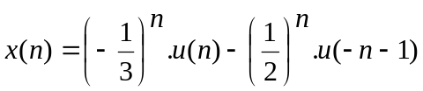
- x[n] = (2)^{n} u[n]
- x[n]=log(1+az⁻¹).

29. .Explain the limit cycle oscillation effect.
30. .Realize the Direct form I and II structure.
3y[n] = x[n] + 2x[n – 1] + 0.5x[n – 2] + 0.8y[n – 2] + y[n – 3] + 3x[n – 3]

31. If there is given a three stage lattice filter with coefficient K₁ = ¼, K₂ = ½ and K₃ = 1/3, determine the FIR filter coefficient for the direct-form structure.
32. An FIR filter is given by, H (z) = 1 + 2z⁻¹ + z⁻². Determine the Lattice filter coefficients and hence draw the lattice structure for above filter.

